Galwad i gynhyrchwyr bwyd!
Dyma’ch cyfle roi cynnig a’r ennill siop/safle cynhyrchu!!
Ydych chi’n gweithio gartref ar hyn o bryd ac yn mynd
yn brin o le i weithio?
Oes gennych chi angen help llaw i gymryd y camau nesaf o fwrdd y gegin i safle cynhyrchu? Rydym yn deall bod cymryd y cam nesaf yn gallu ymddangos fel ei fod yn ormod o risg ac yn rhywbeth rydych yn ei ofni, ond er mwyn eich galluogi i dyfu, datblygu ac ehangu eich busnes i un cynaliadwy, mae angen y lle ychwanegol yna arnoch i gynhyrchu, fân-werthu, allforio a/neu i werthu.
Yn dilyn llwyddiant siop fwyd pop-yp ‘Conwy Naturiol’ oedd yn dathlu a hybu cynhyrchwyr bwyd yng Nghonwy yn 2016, rydym nawr yn gallu cynnig cyfle cyffrous iawn i gynhyrchwyr bwyd Gogledd Cymru.
Gyda’r galw am fwydydd wedi’w gynhyrchu yn lleol yn cynyddu drwy’r amser, rydym wedi adnabod yr angen am gynhyrch lleol ac am safle i gynhyrchwyr lleol i allu ei gynhyrchu!
Mae’r prosiect pop-yp 2017 yn brosiect wedi ei ariannu gan Llywodraeth Cymru fydd yn dechrau ym Medi 2017 ac yn cael ei ariannu hyd at Medi 2019.
- Safle siop amlbwrpas yng nghanol Bae Colwyn y gellir ei ddefnyddio fel safle i gynhyrchu yn unig, neu fel safle cynhyrchu a mân-werthu.
- Rhent am ddim am y 12 mis cyntaf
- Gostyngiad treth busnes
- Yr ail flwyddyn am hanner y rhent
- Cyfrannu at gynllun terfynol dyluniad yr adeilad gan ddefnyddio’r cynllun arfaethedig fel canllaw i’r broses

Blwyddyn 3 - Byddwn yn gwybod erbyn hynny eich bod yn fodel busnes cynaliadwy ac felly bydd cyfrifoldeb y rhent a’r trethi yn disgyn arnoch chi.
Rydym yn hynod o awyddus i glywed gan gynhyrchwyr sy’n gwneud bara a phobyddion, fodd bynnag, byddem yn ystyried ac yn annog ceisiadau gan bob math o gynhyrchu bwyd a diod.
Gofynnwn i chi gwblhau’r ffurflen gais amgaeëdig sy’n dangos datblygiad model busnes cynaliadwy dros y 3 blynedd nesaf.
Rydym yn gofyn i bob un sydd â diddordeb i ymweld â’r safle i weld a fyddai’n addas ar gyfer eich dibenion. Bydd ymweliadau ar y dyddiadau canlynol: Dydd Gwener y 14eg o Orffennaf 1.30yp - 6.30yh, Dydd Llun y 17eg o Orffennaf 10.00yb - 2.00yp a dydd Mawrth y 18fed o Orffennaf 10.00 yb - 12.30 yp (Cysylltwch ag Alwen neu Sarah i drefnu ymweliad)
Dyddiad cau ar gyfer ceisiadau : AWST 18^{eg} 2017
Os oes gennych unrhyw gwestiynau, cysylltwch â;
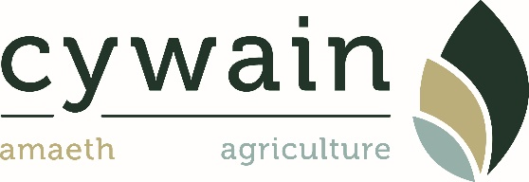
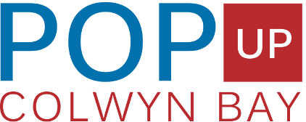
Alwen Eidda: alwen.eidda@menterabusnes.co.uk neu Sarah Wilkie: sarah@shcreatives.co.uk

FFURFLEN GAIS PROSIECT CYNHYRCHWYR POP-YP 2017
Enw’r busnes;..………………………………………………………………….…..……………………………………………………………
Enw cyswllt;....…………………………………………………………………………………………………………………………………….
Cyfeiriad;……………………………………………………………………………………………………………………………………………
Rhif ffôn;….…………………………………………………………………………………..
Ebost;……………………………………………………………………………………………
Pa gynhyrchion ydych chi’n eu cynhyrchu ar hyn o bryd;

Ble ydych chi’n gwerthu eich cynnyrch;

Sut fyddech chi’n disgwyl i’ch busnes dyfu o fewn 12 mis o dderbyn safle’r siop;

Sut fyddech chi’n disgwyl i’ch busnes dyfu ym mlwyddyn 2 a 3;

Fyddwch chi’n gwneud cynnyrch arall o’r siop yn ychwanegol i beth rydych chi’n ei gynhyrchu nawr;

Sut fydd y siop yn cynorthwyo eich busnes;

Unrhyw wybodaeth berthnasol arall i gryfhau eich cais;

Dylech gynnwys copïau o’r canlynol os gwelwch yn dda;
- Tystysgrif Hylendid Bwyd
- Yswiriant Busnes
- Unrhyw ddogfennau eraill sydd ei angen i redeg eich busnes
Cynllun drafft o ddyluniad y safle (amlygwch unrhyw beth fyddwch ei angen e.e. ffitiadau, celfi a chyfarpar)

Calling all food producers!
This could be your chance to win a shop/production area!!
Currently working from home and running out of space or your workspace is becoming a bit of a squeeze?
Do you need that little helping hand in taking the next step from kitchen table top to produce/shop space. We understand that taking the next step can seem risky and daunting but in order to grow, develop and expand into a sustainable business you just need that extra space to produce, retail, export and/or sell.
After a successful pop up food shop ‘Natural Conwy’ which celebrated and promoted food producers of Conwy in 2016. We are now able to offer the exciting opportunity to food producers of North Wales.
With the demand for locally produced foods and edibles ever increasing we have identified that there is a need for local produce and a need for spaces for local producers to produce!
The pop up producers project 2017 is a Welsh government funded project that will start in September 2017 and will be funded until September 2019.
- A versatile shop space in the heart of Colwyn bay which can be used as production space only or as production and retail space.
- First 12 month rent free
- Business rate relief
- Year 2 half rent
- Contribute to the final design of the layout of the building using their proposed plan to guide this process.

Year 3 - We know by then that you will be a sustainable business model so we will hand over the responsibility of rent and rates to you.
We are particularly keen to hear from producers who are bread makers & bakers, however we will consider and encourage application from all food disciplines of food and drink production.
We ask that you fill in the enclosed application form that demonstrates the development of a sustainable business model over the next 3 years.

We ask that all interested parties visit the space to check suitability of purpose there will be viewings to do this on the follow dates: Friday 14th July 1.30pm - 6.30pm, Monday 17th July 10.00am - 2pm & Tuesday 18th July 10am - 12.30pm (Please contact Alwen or Sarah to arrange viewing)
Deadline for applications: AUGUST 18th 2017
For any questions or enquiries please contact;
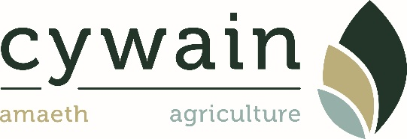
Alwen Eidda: alwen.eidda@menterabusnes.co.uk or Sarah Wilkie: sarah@shcreatives.co.uk
POP UP PRODUCERS PROJECT 2017 APPLIATION FORM
Business Name;………………………………………………………………….…..……………………………………………………………
Contact Name;…………………………………………………………………………………………………………………………………….
Address;………………………………………………………………………………………………………………………………………………
Telephone;…………………………………………………………………………………..
Email;……………………………………………………………………………………………
What products do you currently produce;

Where do you currently sell your products;

How do you expect your business to grow within the first 12 months of receiving the shop space;

How would you expect your business to grow in year 2 & 3;

Will you be producing other products from the shop to what you produce now?;

How will the shop benefit your business;

What other relevant information can you give to strengthen your application;

Please include copies of the following;
- Food hygiene Certificate
- Business Insurance
- Any other relevant documents that are required to run your business
Draft plan for layout of space (Highlighting any requirements needed e.g Fixtures, fittings and equipment)

